Calvin Saechao

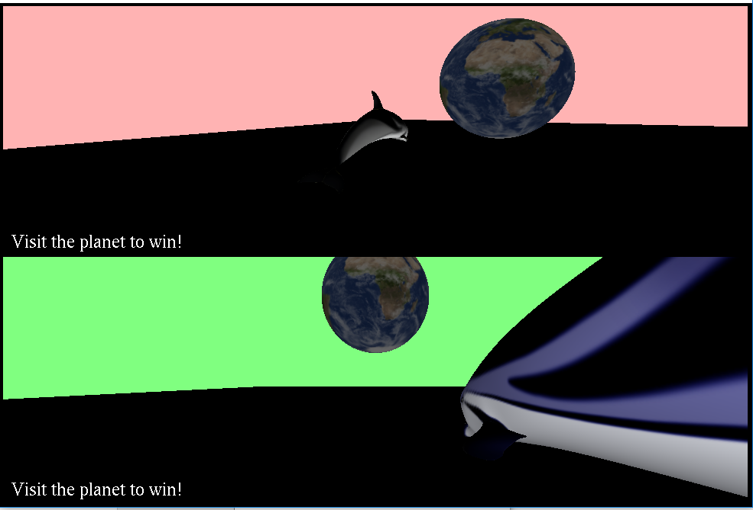

How to compile: In the Saechao-Calvin-a2 folder, it has a run.bat file that will automatically compile then run the game.

How to play:

Controls (Both Players):

* W/A/S/D or left joystick to move forward/backward/left/right
* SPACE/SHIFT or R1/R2 to move up/down
* Q/E or R1/R2 to zoom in/out
* Arrow keys or right joystick to move orbiting camera

1. Whoever gets to planet Earth wins!
   1. Player 1 will make the planet move up and down, saving the moon from Player 2.
   2. Player 2 will steal the moon from the Earth (moon will start orbiting Player 2).
2. If you win or lose, the HUD will show it.

Node Controllers:

1. Moves planet up or down if Player 1 visits it.
2. Makes the moon orbit the earth or the dolphin of Player 2.

Node group/child:

* The moon initially is the child of the earth and orbiting the earth, when visited by Player 2, it becomes the child of Player 2 and starts orbiting Player 2.

Camera Control Description:

* It can zoom in and out, rotate around, and rotate up and down. When the dolphin node moves, it will update the position of the camera relative to the dolphin given the specified radius, azimuth, and elevation.
* Orbit controller

Missing requirements: None

Special stuff:

* Changed the target for the moon orbit when Player 2 visits the moon.
* The dolphins can move up or down and cannot go through the floor.

Assets Used:

* From Dolphin Click example:
  + Sphere.obj
  + Earth.obj